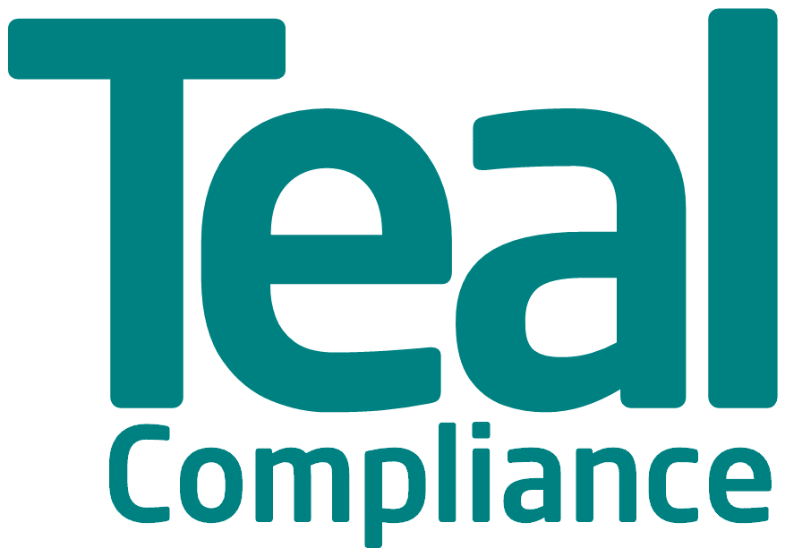
Course Booking Form
Please complete the online booking form.
By completing this form, you are making a formal course booking and the terms and conditions (attached) will apply.
Course Details:
Course | Compliance Officer Training Programme
Duration | 15 weeks beginning on 1st February 2019
Cost | £2,000 per Delegate

Delegate Information
Name
Organisation
Telephone
Email

Invoicing Information
Organisation
Address 1
Address 2
City
Postcode

General
Where did you find out about this course?
Would you like to be included on our Mailing List (Individual or Firm)? *

We do not sell or share your information with anyone. We only collect information like your name, email address, mailing address, phone number, and billing information so we can provide the email marketing services described on our website:
https://www.tealcompliance.com
Signature
Dated

I agree to the Course Terms and Conditions ☐

Return completed form to hello@tealcompliance.com

