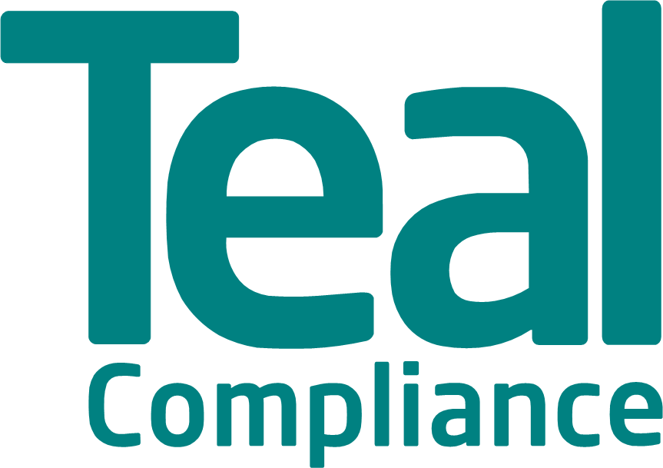
Teal Compliance
High Risk Jurisdiction List: April 2020
Explanatory notes:

- CPI scoring and ranking for jurisdictions as per risk of corruption published by Transparency International. The lower the CPI score the higher risk of corruption. Countries of particular high risk are marked in red i.e. scores of 40 and below.
- OFSI - Office of Financial Sanctions Implementation, UK issued financial sanctions regime list
- OFAC- Office of Foreign Assets Control, US sanctions regime list
- FATF – Financial Action Task Force, list of countries identified as High-Risk Jurisdictions “subject to a Call for Action” and Jurisdictions under “Increased Monitoring” aka “grey list” (country has committed to resolve swiftly the identified strategic deficiencies within agreed timeframes).
- The list includes:
- Countries with arms embargos issued against them
- OSCE/Arab League/Israel sanctioned countries
- UN sanctions countries
- EU high risk third countries

NB for guidance purposes only. To be relied upon entirely at own risk.

Country | CPI Score 2018 | CPI Rank | UN | EU | US | Financial Action Task Force | Other | EU List of high risk third countries
Afghanistan | 16 | 172
Albania | 36 | 99
Algeria | 35 | 105
Angola | 19 | 165
Argentina
Armenia | 35 | 105
Australia | 77 | 13
Austria | 76 | 14
Azerbaijan | 25 | 152 |  |  |  |  | Organisation for Security and Co-operation in Europe
Bahamas | 65 | 29
Bahrain | 36 | 99
Bangladesh | 26 | 149
Barbados | 68 | 25
Belarus | 44 | 70
Belgium | 75 | 17
Benin | 40 | 85
Bhutan | 68 | 25
Bolivia | 29 | 132
Bosnia and Herzegovina | 38 | 89
Botswana | 61 | 34
Brazil | 35 | 105
Brunei Darussalam | 63 | 31
Bulgaria | 42 | 77
Burkina Faso | 41 | 78
Burundi | 17 | 170
Cabo Verde | 57 | 45
Cambodia | 20 | 161
Cameroon | 25 | 152
Canada | 81 | 9
Central African Republic | 26 | 149
Chad | 19 | 165
Chile | 67 | 27
China | 39 | 87 |  | Arms embargo
Colombia | 36 | 99
Comoros | 27 | 144
Congo | 19 | 165
Costa Rica | 56 | 48
Côte D'Ivoire | 35 | 105
Croatia | 48 | 60
Cuba | 47 | 61 |  | EU Anti blocking applies
Cyprus | 59 | 38
Czech Republic | 59 | 38
Democratic Republic of the Congo | 20 | 161
Denmark | 88 | 1
Djibouti | 31 | 124
Dominica | 57 | 45
Dominican Republic | 30 | 129
Ecuador | 34 | 114
Egypt | 35 | 105
El Salvador | 35 | 105
Equatorial Guinea | 16 | 172
Eritrea | 24 | 157
Estonia | 73 | 18
Ethiopia | 34 | 114
Finland | 85 | 3
France | 72 | 21
Gabon | 31 | 124
Gambia | 37 | 93
Georgia | 58 | 41
Germany | 80 | 11
Ghana | 41 | 78
Greece | 45 | 67
Grenada | 52 | 53
Guatemala | 27 | 144
Guinea | 28 | 138
Guinea Bissau | 16 | 172
Guyana | 37 | 93
Haiti | 20 | 161
Honduras | 29 | 132
Hong Kong | 76 | 14
Hungary | 46 | 64
Iceland | 76 | 14
India | 41 | 78
Indonesia | 38 | 89
Iran | 28 | 138
Iraq | 18 | 168
Ireland | 73 | 18
Israel | 61 | 34 |  |  |  |  | Arab League
Italy | 52 | 53
Jamaica | 44 | 70
Japan | 73 | 18
Jordan | 49 | 58
Kazakhstan | 31 | 124
Kenya | 27 | 144
Korea, North (DPRK) | 14 | 176
Korea, South | 57 | 45
Kosovo | 37 | 93
Kuwait | 41 | 78
Kyrgyzstan | 29 | 132
Lao PDR
Laos | 29 | 132
Latvia | 58 | 41
Lebanon | 28 | 138
Lesotho | 41 | 78
Liberia | 32 | 120
Libya | 17 | 170
Lithuania | 59 | 38
Luxembourg | 81 | 9
Macedonia | 37 | 93
Madagascar | 25 | 152
Malawi | 32 | 120
Malaysia | 47 | 61
Maldives | 31 | 124
Mali | 32 | 120
Malta | 54 | 51
Mauritania | 27 | 144
Mauritius | 51 | 56
Mexico | 28 | 138
Moldova | 33 | 117
Mongolia | 37 | 93
Montenegro | 45 | 67
Morocco | 43 | 73
Mozambique | 23 | 158
Myanmar | 29 | 132
Namibia | 53 | 52
Nepal | 31 | 124
Netherlands | 82 | 8
New Zealand | 87 | 2
Nicaragua | 25 | 152
Niger | 34 | 114
Nigeria | 27 | 144
Norway | 84 | 7
Oman | 52 | 53
Pakistan | 33 | 117
Panama | 37 | 93
Papua New Guinea | 28 | 138
Paraguay | 29 | 132
Peru | 37 | 105
Philippines | 36 | 99
Poland | 60 | 36
Portugal | 64 | 30
Qatar | 62 | 33
Romania | 47 | 61
Russia | 28 | 138
Rwanda | 56 | 48
Saint Lucia | 55 | 50
Saint Vincent and the Grenadines | 58 | 41
Sao Tome and Principe | 46 | 64
Saudi Arabia | 49 | 58
Senegal | 45 | 67
Serbia | 39 | 87
Seychelles | 66 | 28
Sierra Leone | 30 | 129
Singapore | 85 | 3
Slovakia | 50 | 57
Slovenia | 60 | 36
Solomon Islands | 44 | 70
Somalia | 10 | 180
South Africa | 43 | 73
South Sudan | 13 | 178
Spain | 58 | 41
Sri Lanka | 38 | 89
Sudan | 16 | 172
Suriname | 43 | 73
Swaziland | 38 | 89
Sweden | 85 | 3
Switzerland | 85 | 3
Syria | 13 | 178
Taiwan | 63 | 31
Tajikistan | 25 | 152
Tanzania | 36 | 99
Thailand | 36 | 99
Timor-Leste | 35 | 105
Togo | 30 | 129
Trinidad and Tobago | 41 | 78
Tunisia | 43 | 73
Turkey | 41 | 78
Turkmenistan | 20 | 161
Uganda | 26 | 149
Ukraine | 32 | 120 |  |  | Crimea/Sevastopol and Russian Federation
United Arab Emirates | 70 | 23
United Kingdom | 80 | 11
United States of America | 71 | 22
Uruguay | 70 | 23
Uzbekistan | 23 | 158
Vanuatu | 46 | 64
Venezuela | 18 | 168
Vietnam | 33 | 117
West Bank |  |  |  |  |  |  | Israel – Arabic countries prohibit transactions involving Israel
Yemen | 14 | 176
Yugoslavia
Zambia | 35 | 105
Zimbabwe | 22 | 160

